| Package Create | ros2 pkg create --build-type ament_python <Name of package> --dependencies <dependency 1> <...>  <Do Not Use Capital Letters> |
| --- | --- |
| setup.py: Setting up the console_scripts | “<executable name> = <folder_name>.<file_name>:<funtion_name>” |
| Create publisher | self.create_publisher(msg_type, topic name, int) |
| Create subscriber | self.create_subscription(msg_type, topic name, callback, int) |
| Check current internet | ip a |
| Check topic data | ros2 topic echo <topic name> |
| Check env | rosenv |
| Reboot robot | sudo reboot |
| Check wifi | nmcli dev wifi |
| Check topic type | ros2 topic type <topic name> |

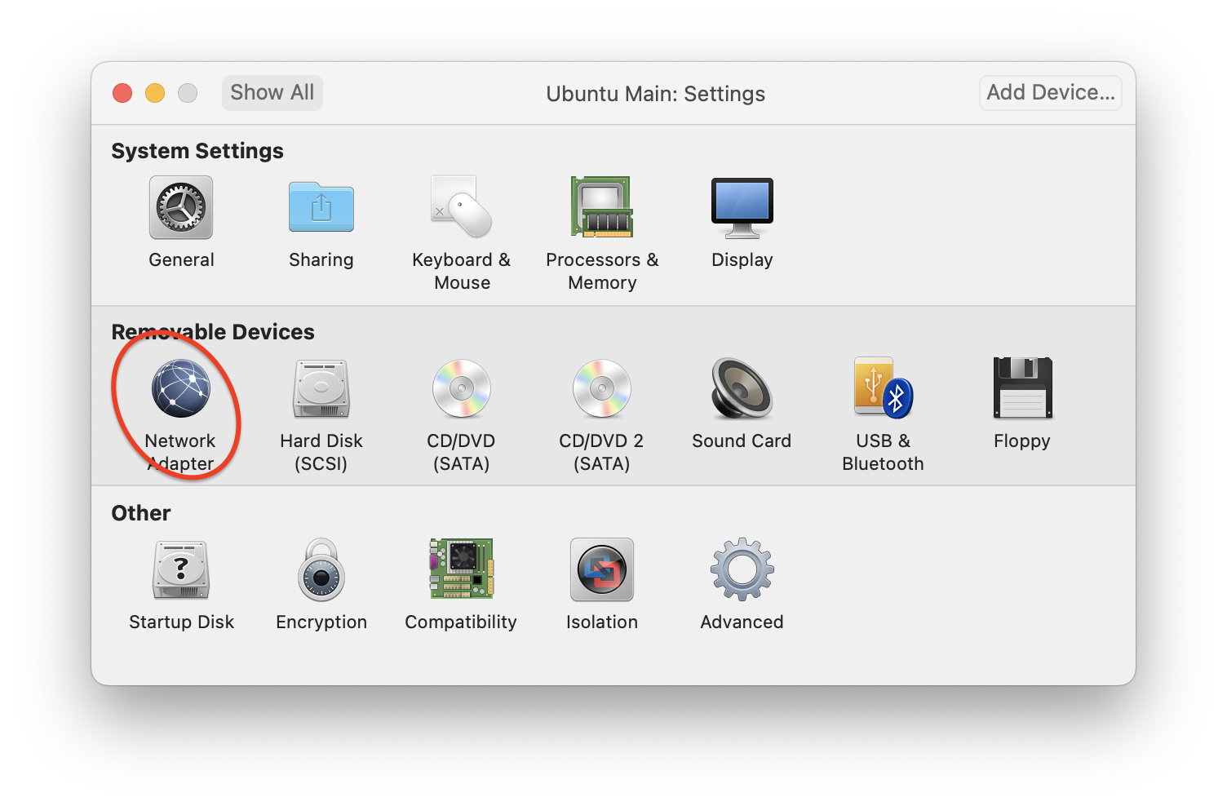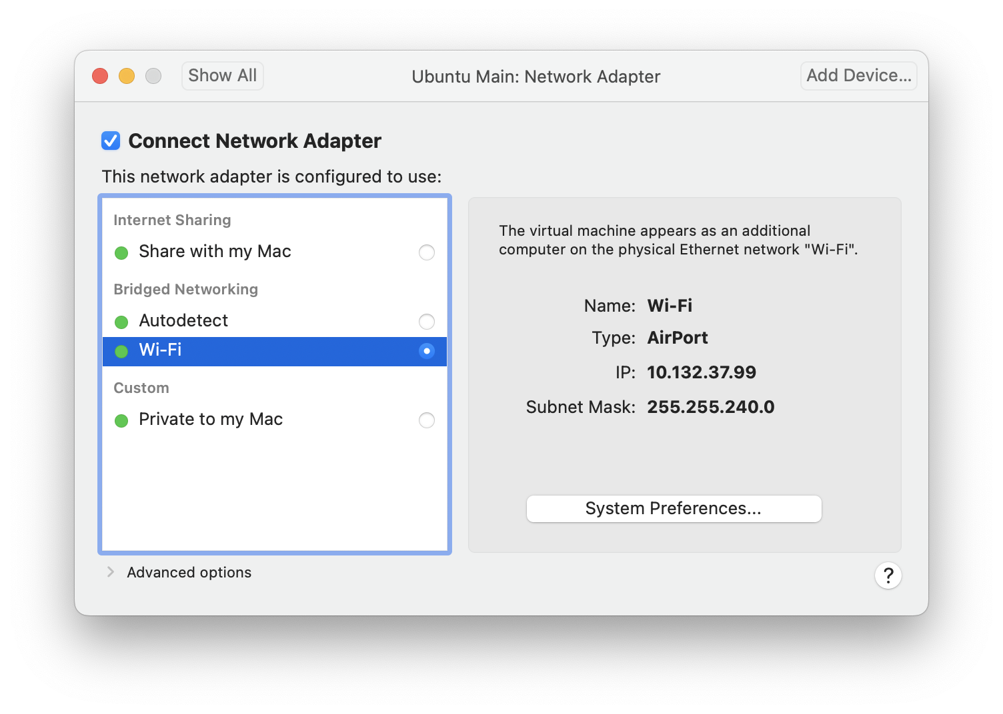

Jayce:

| To source the setup bash file: | Source ~/aiil_workspace/bin/install/setup.bash |
| --- | --- |
| To source the setup bash file: | source /opt/ros/humble/setup.bash |
| To test connection/ping the robot | ping <ROBOT>/ ssh husarion@192.168.100.<NAME>.local |
| If connection failed: | export ROS_DOMAIN_ID = 0 |
| Setup packages: | . install/setup.bash |
| Checking whos connecting to robotsync | Who |
| Robot moving test: | ros2 run teleop_twist_keyboard teleop_twist_keyboard |
| To initialise the robot everytime : | ./ros_driver_start.sh all |
| Syncing files into robot: | /.aiil_workspace/bin ./rosbot_sync -r |
| Deleting files | /.aiil_workspace/bin ./rosbot_sync -d |
| To build a package : | ros2 pkg create --build-type <NAME> |
| To building/compiling packages | colcon build --packages-select OURPACKAGE |
| To run files in package | ros2 run PACKAGE FILE |
| Cyclone update | Sudo apt -get install -y ros-humble-rmw-cyclonedds-cpp |

Robot Access workflow:

ssh into the robot

./ros_driver_stat.sh all

In a new terminal window : set_ros_domain <robot name>

rviz2 -d aiil_workspace/humble_workspace/src/aii_rosbot_demo/rviz/rosbot_default.rviz

Robot package workflow

1. Syncing the files into the robot /.aiil_workspace/bin ./rosbot_sync -r
2. Getting into the docker by ./docker_aiil.sh or ./aiil_docker.sh
3. colcon build in docker image
4. Source the setup file
5. Run! ros2 run <package> <executable>